Week 4: Hands-on 1: Create a Spring Web Project Using Maven

**step-by-step setup process for creating a Spring Boot web project**

1. Go to https://start.spring.io.

2. Change Group to ‘comt.cognizant’.

3. Change Artifact Id to ‘spring-learn’.

4. Select dependencies: Spring Boot DevTools and Spring Web.

5. Click on Generate to download the project zip file.

6. Extract the zip file to a desired location.

7. Open IntelliJ IDEA → File → Open → Select the extracted folder.

8. Wait for Maven to resolve dependencies.

9. Open SpringLearnApplication.java and add logs using SLF4J to verify if the main() method is executed.

10. Run the application from IntelliJ. Console should display log output indicating successful startup.

## Spring Initializr Configuration Screenshot

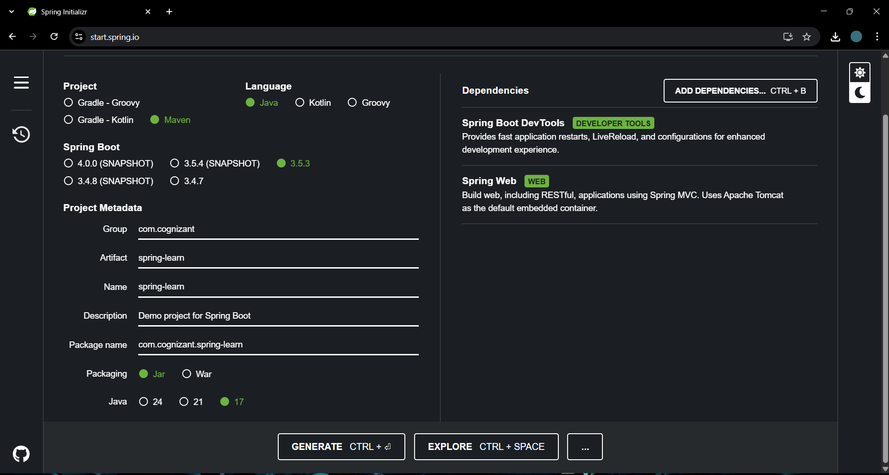

## IntelliJ Console Output Screenshot

